Program Scope Change Request

INSTRUCTIONS

Any change to a grant proposal post-approval requires review and approval by the IME Team prior to implementation of scope change(s) and program initiation. Requestors must notify BMS of any changes to the approved grant proposal, per the Letter of Agreement (LOA), immediately and no fewer than 60 days prior to the original program start date.

Changes to request elements requiring review include, but are not limited to:
- Addition or deletion of activities
- Support
- Reduced number of intended supporters, particularly conversion from multi-support to single support, reduced level of secured funding, or insufficient funding to deliver original proposal
- Excess funding including requested support and any attendee registration fees
- Intended purpose, goals/learning objectives of proposed program or activities
- Educational partner or accredited provider
- Modality (any change in activity type)
- Date, time, and venue/location of live activities
- Launch date and/or expiration date of enduring activities
- Continuing education certification
- Outcomes analysis and timing of outcomes report submission

The Program Scope Change Request Form and a revised BMS Program Budget (in instances where the change in scope impacts the program costs) must be submitted to the Grants & Giving department at BMS for review. Revised budget information must be provided using the BMS budget template; click HERE and look in the template drop down folder to download Program Scope Change Request Form (applicable to IME requests only). Final decisions regarding scope change requests will be communicated to the requestor by the Grants & Giving department.

Submit your completed Program Scope Change Request Form and revised budget (if applicable) to the Cybergrants portal. Utilizing the following steps:

- Sign into the portal and scroll down to the section titled “Impact Reports requiring Action”
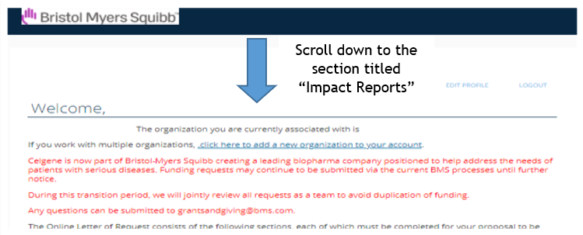

- Click on the Change of Scope associated with the Request ID that requires a Change of Scope submission
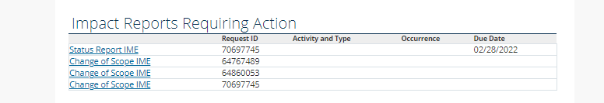
If the scope change request is approved, the Program Scope Change Request Form and any supporting documentation (e.g., revised BMS Program Budget) will become official documentation for the existing grant proposal. If a scope change is not submitted or the request is not approved, the LOA may be nullified according to the Terms and Conditions described therein. Any funds already provided toward start of the activity must be returned to BMS within 15 business days. A paper check (with the grant ID included within the MEMO) should be mailed to:
Bristol Myers Squibb
Attn: Thomas Vilorio
3401 Princeton Pike
Lawrenceville, NJ 08648

Program Scope Change Request Form

Please complete the following information and submit to the Cybergrants portal no fewer than 60 days prior to the activity’s start date.

Reason for Change of Scope Request

Your grant ID #

Form submitted by: _________________Email_____________________

Indicate all relevant types of proposed changes:

☐ | Additions to approved  grant | ☐ | Deletions from approved grant | ☐ | Other changes to approved grant

Proposed scope changes (Describe changes requested for all elements in the initial proposal that are affected by the request):
If no changes please indicate by stating “no changes.

Request Element | Original Proposal | Requested Change
Program Title
Overall Description (activity details)
Program Partner
# of live activities
Potential live reach
(estimated # of learners)
Live start date
Live end date
# of enduring activities
Potential enduring reach (estimated # of learners)
Enduring activity launch date
Enduring activity end date
Learning objectives
Cost per learner, estimate
Interim outcomes report due dates*
Final outcomes report due date*
Changes to Crediting (# or type of CME/CE credits)
Other changes

BMS Internal Use Only

*Please refer to the BMS Guidance for IME Outcomes Reports for questions pertaining to due dates and timing of the interim and outcomes reports. This guidance can be downloaded by clicking HERE under the Outcomes Reporting heading.

