Investigator Quick Reference Guide

General Notes and Tips

- You will need to click the Save button at the bottom right corner of any form in order for your information to be saved.
- FastTrack has a security timeout feature when the system is idle for an extended period of time. You will be required to log back into the system after sixty minutes of inactivity. If you are working on a record and leave it open while performing other tasks, we recommend that you navigate to the bottom of the record, and click the Save button. This will prevent you from losing any data you have already entered.
- * [Asterisks] indicate a required field.
- This document will indicate up to 5 values in drop-down lists within FastTrack; where the value lists are longer than 5 this will be noted.
- It is recommended that you save as you go. You don’t have to have all the required fields populate; the draft will be available for you on your home page when you are ready to come back to it.
- You will not be able to move onto the next page if a required field has not populated.
- Once you’ve completed a section, you can move back and forth by clicking the tabs at the top of the page or clicking on the back bottom at the lower left of the page.

We are committed to providing you with answers to your questions and concerns. Please contact us using the information below, and we will respond to your inquiry as quickly as possible.
Study Support
Please contact BMS via FastTrack
Technical Support
Main Number: +1 844 439 5499 US only. For Outside US, please see the International numbers at the end of the guide.
Main Email: hd‐sci‐apps@bms.com

Registering for Access and Logging In

To register for access to the website, navigate to https://fasttrack.bms.com/

You will first need to register for the FastTrack portal.
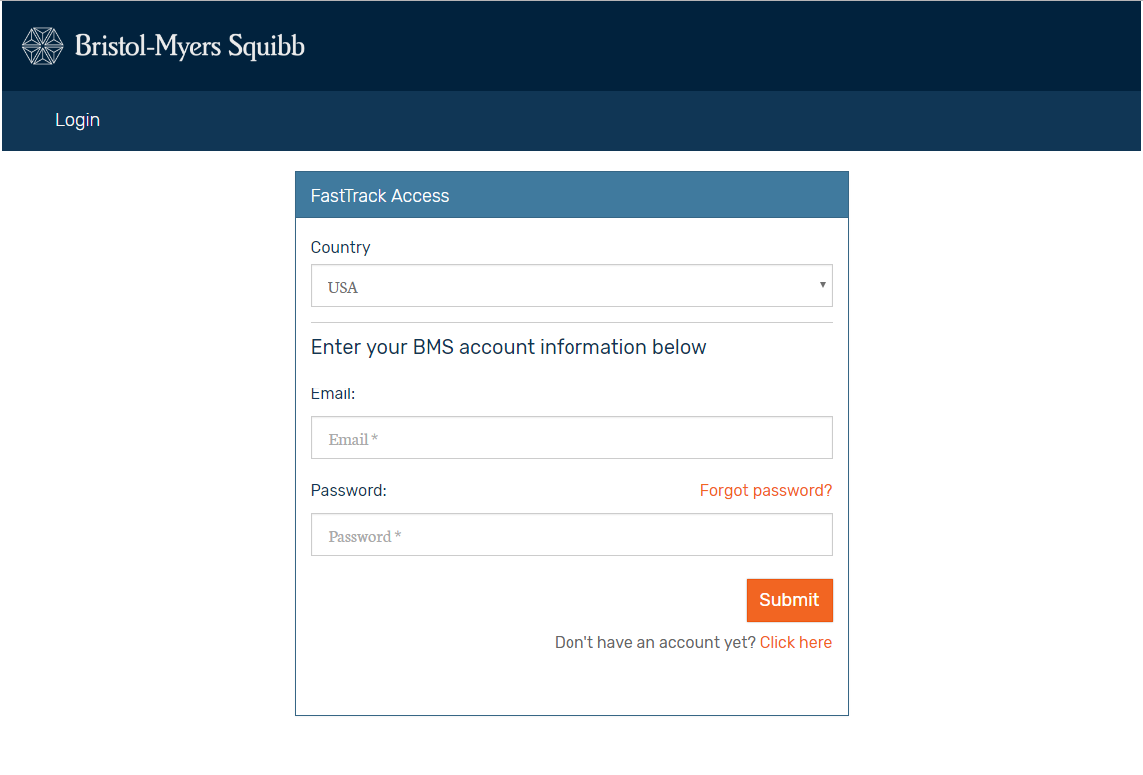

You will then be asked to complete your profile in the system. The first section covers “Your details”. These fields will be mandatory:
First Name, Last Name, Institution Name, Institution Address, City, Postal Code, State/Province.

Next, you will be asked to provide “Your professional details”.
These fields will be mandatory:
Title, Profession, Email Address and Password.

When you have completed these fields, simply click Submit and you will be brought to your Home page.
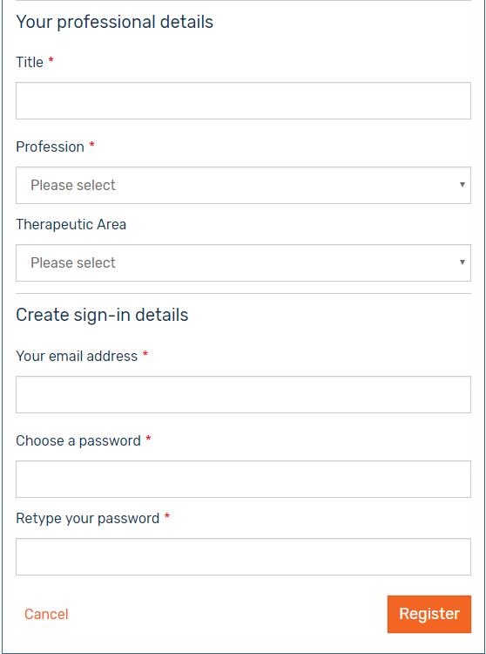

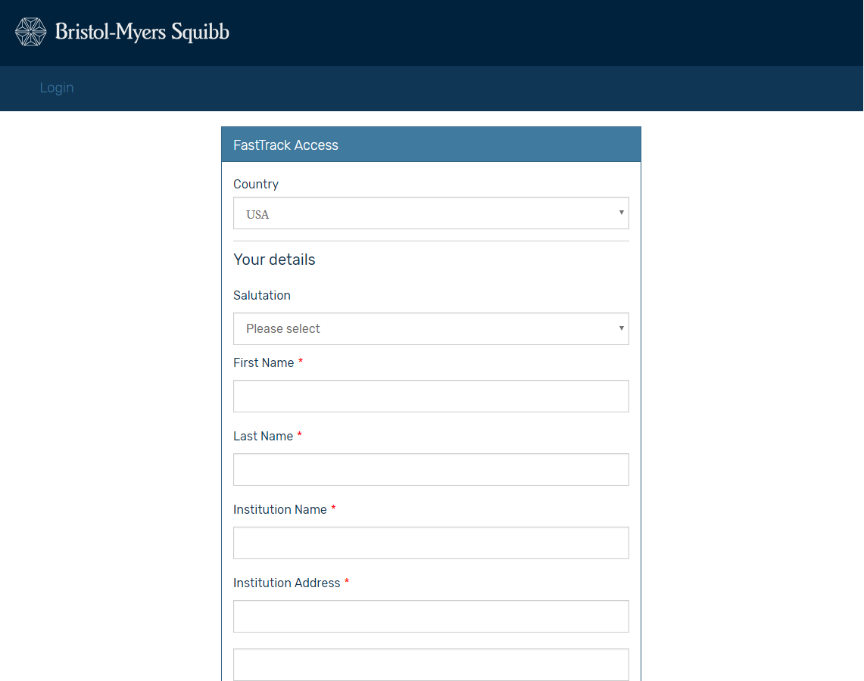

Enter your email address and your password. If you have forgotten your password, you can click the “Forgot your password?” link to have it reset and resent to you. If you have forgotten your email address used to set up this account, US investigators call +1 844 439 5499. For Investigators outside the US, please see the list at the end of the guide for International numbers.

Submitting New Investigator Sponsored Research Concept

When creating a new request, you will first be asked to provide the Investigator’s Information. There will be a box to check if you are the primary investigator. Checking this box will remove the requirement to identify a role, first name, last name and email as this information will be taken from the investigator profile that you provided when first registering.

If you are not the Primary Investigator, you must complete this section.

Enter the Investigator's Information

My Role*
This is a mandatory field with a drop-down list. You will be asked to choose between the following values:
- Co-Investigator
- Regulatory Document Coordinator
- Site Legal Contact
- Study Site Coordinator
- Sub-Investigator
- Other

Investigator First Name* This is a mandatory field.

Investigator Last Name* This is a mandatory field.

Investigator Email* This is a validated mandatory field – for email format.

Enter the Institution Information
The institution will auto-populate from your primary investigator profile. If this is not the correct institution, you will need to enter all mandatory fields. There is also a set of “Institution Address” fields below the Institution Name (i.e. Institution Address Line 1, etc.) and above the Shipping Address fields. There is also a checkbox that says “Shipping Address same as Institution Address?” If this is checked, the Shipping Address fields below will become hidden and not need to be entered. Otherwise, these can be entered manually just like the Institution address fields.
Institution* This is a mandatory field.

Shipping Address Line 1* This is a mandatory field.

Shipping Address Line 2 This is NOT a mandatory field.

Shipping City* This is a mandatory field.

Shipping State / Province* This is a mandatory field for the US/Canada

Shipping Postal Code* This is a mandatory field.

STUDY DETAILS

Study Type*
This is a mandatory field. You will be asked to choose between the following values:
- Interventional
- Non-Interventional without Patients
- Non-Interventional with Patients

Study Subtype* This is a mandatory field. The study subtype values change dependent upon the study type. You will be asked to choose between the following values, by study type:
Study Types
 | Interventional | Non-Interventional without Patients | Non-Interventional with Patients
Sub-Types | Interventional | Prospective | Prospective
 |  | Retrospective | Retrospective
 |  | Prospective and Retrospective | Prospective and Retrospective
 |  |  | Registry

Short Title*
This is a mandatory field.

Therapeutic Area*
This is a mandatory field with a drop-down list. You will be asked to choose between the following values:
- Cardiovascular Disease
- Immunoscience
- Metabolic Diseases
- Neuroscience
- Oncology
- Virology

Disease Area*
This is a mandatory field with a drop-down list. You will be asked to choose from an extensive list of values.

Phase*
This is a mandatory field with a drop-down list. You will be asked to choose from an extensive list of values.

Planned Start Date* This is a mandatory field with a pop-up calendar to select a date.

Planned # of Sites* This is a numeric value mandatory field

Planned Trial Duration (# of Months)* This is a numeric value mandatory field.
Planned # of Patients Enrolled* This is a free-form mandatory field.

Local BMS Contact Name This is NOT a mandatory field.

Requested Resource*
This is a mandatory field with a drop-down list. You will be asked to choose between the following values:
- Funding
- Drug and Funding
- Drug
- Other

If you select “Funding” or “Drug and Funding” then two additional fields will appear that are also mandatory:
- Total Budget Requested
- Budget Currency

Primary Compound*
This is a mandatory field with a drop-down list. You will be asked to choose from an extensive list of values.

Primary Indication*
This is a mandatory field with a drop-down list. You will be asked to choose from an extensive list of values.

If you need to request additional compound(s), you will check a box and an additional Compound and an additional Indication field will appear. Both will be mandatory and will be an extensive drop-down list of values.
Study Rationale: Provide a brief description of the medical question and the rationale of how this trial addresses the question. Provide a rationale for the dose schedule outlined for all treatment arms. Reference any non-labeled indication.

* This is a free-form mandatory field

Primary Objective: Provide the main goal of the study and the study population. Provide a detailed definition that is directly linked to the primary objective. In some cases, the detailed description may be more appropriate in the statistical section.

* This is a free-form mandatory field

Primary Endpoint*
This is a free-form mandatory field

Hypothesis*

This is a free-form mandatory field

Study Assessments: Specify type and frequency of safety, efficacy, and outcome measures. Also indicate the method(s) used to assess measures.

This is a not a mandatory field.

Secondary Objective

This is a not a mandatory field.

Data and Statistical Plan: Describe the planned statistical analysis including timing of the primary and secondary measurements and sample size calculation. The range of sophistication will depend on a number of factors, including the size and complexity of the study.
* This is a free-form mandatory field

References: List references, studies, and sources that support the study design.
This is a not a mandatory field.

Will you receive funding from other sources?*
This is a yes/no mandatory radio button selection. If you choose yes, you will be asked to specify.
Will a government review be required?*

This is a yes/no mandatory radio button selection. If you choose yes, you will be asked how many reviews the study will undergo
Targeted Patient Population: Specify age, gender, and other demographic information for the trial population.

This is a not a mandatory field.

Estimated Contract Review Time: Provide this in number of weeks or months.
This is a not a mandatory field.

Specify the dose, schedule, duration, and any pre-medications, etc.
This is a not a mandatory field.

Participating Countries*
There will be a drop-down country list to choose from for this response.

How often does your IRB/IAC meet?*
This is a mandatory field with a drop-down list. You will be asked to choose between the following values:
- Daily
- Weekly
- Bi-Weekly
- Monthly
- Bi-Monthly
- Other
If you answered "Other", you will need to provide a short description –which will be a mandatory field.

Sample Size Calculation*
* This is a free-form mandatory field.

Sample Size Justification: The sample size must reference the primary endpoint.*

* This is a free-form mandatory field.

List any correlative studies.*
* This is a free-form mandatory field. If there are no correlative studies please enter N/A.

Key Inclusion Criteria: List the inclusion criteria necessary to support the trial design and drug safety requirements.
* This is a free-form mandatory field.

Key Exclusion Criteria: List the exclusion criteria necessary to support the trial design and drug safety requirements.
* This is a free-form mandatory field.

Secondary Endpoint
This is a not a mandatory field.

Would you like to add planned publication information to this request?*

Yes No
This is a yes/no mandatory radio button selection. If you choose yes, then an additional tab at the top will appear and you will be required to specify the planned publication indicated after the SUSAR section below.

Add SUSAR Contacts Below
SUSAR: Suspected Unexpected Serious Adverse Reaction
If needed, you can add multiple SUSAR Contacts here by clicking “+Add SUSAR Contact”.
SUSAR Contact Name*
* This is a free-form mandatory field.

SUSAR Contact Email*
* This is a validated mandatory field – for email format.

Country
There will be a drop-down country list to choose from for this response.

Enter the Planned Publication Information Below
Publication Type*
This is mandatory when you choose the Yes radio button for planned publications. You will be required to choose from one of the following drop-down values:
- Abstract
- Manuscript
- Poster
- Other

Planned Publication Date*
This is a mandatory field with a pop-up calendar to select a date.

Planned Journal Title
This is a not a mandatory field.

Planned Congress Name
This is a not a mandatory field.

Add Related Documents Below
Curriculum Vitae*

This is a mandatory field requiring you to upload a file.

The following fields are NOT mandatory; however you are free to upload any additional documents.
- Other Curriculum Vitae
- References/Relevant Literature

- Supporting Document(s) 1 -4

International contact numbers for BMS Help Desk

Help Desk Phone Numbers | Toll Free
Argentina | 0800 666 1071
Australia | 1 800 506 758
Austria | 0800‐005910
Belgium | 0800 764 18
Brazil | 0800 891 5625
Bulgaria | 0808 101 3509
Canada | 866 909 5700
China ‐ North | 10800 713 1387
China ‐ South | 10800 130 1345
Colombia | 1 800 518 1050
Czech Republic | 800‐143583

Denmark | 808 898 69
Dominican Republic | 1 866 685 1182
Egypt | 8000000567
France | 0800 911 214
Germany | 0800 180 1681
Greece | 00800‐12‐8174
Holland/Netherlands | 0800 023 2647
Hong Kong | 800 930 344
Hungary | 06800 16 920
India | 000 800 100 3451
Indonesia | 001 803 015 203  5739
Ireland | 1800936294
Italy | 800 874 029
Italy ‐ Latina | 800 874 029
Italy ‐ Anagni | 800 874 029
Japan | 00531 13 1432
Korea | 308 132 264
Malaysia | 1800 81 4462
Mexico | 1 800 267 4357
Norway | 800‐111‐65
Peru | 0800 53 963
Philippines | 1800 1116 0970
Poland | 00‐800‐1213633
Portugal | 800 863 249
Puerto Rico | 1 800 723 7223
Romania | 800 896868
Russia | 8‐10‐8002‐6984011
Saudi Arabia | 800 844 2544
Singapore | 800 1301 705
Slovakia | 0800‐001604
Spain | 900 931 312
South Africa | 080 09 83157
Sweden | 020 793 303

Switzerland | 0800 894 178
Taiwan | 801 14 8913
Thailand | 001 800 13203 5739
UK | 0808 101 3509
United Arab Emirates (UAE) | 80004445767
US | 888 930 5700

